# Abstract

Over Speeding is one of the main reasons for the increase in the occurrence of accidents nowadays. Many techniques are being used currently for monitoring the speed of the vehicles on roads. However, these methods require a lot of manpower. So, the objective of this project is a speed detection system for vehicles on the highway road using Arduino thereby reducing manpower. Accidents occurring due to rash driving on highways are on the rise and people are losing their lives because of others' mistakes. It is necessary to solve these kinds of problems through electronic circuits. This system will come handy for highway traffic police as it will not only provide a digital display in accordance with a vehicle’s speed but also sounds an alarm if the vehicle exceeds the limit speed for the highway.

The proposed system calculates the real time speed of the vehicle using an IR Speed sensor. If the speed of any vehicle exceeds the prescribed speed limit for the third time, the driver will be alerted through a buzzer indicating the same. If the driver still does not drive within the speed limit an over speeding challan will be issued against the same vehicle.

**Keywords:** Speed detection, IR Sensor, Buzzer, Arduino UNO, LCD Display.

# Introduction

The violation of traffic rules and regulations has contributed highly to the notable increase in the number and severity of road accidents. Most of these road accidents are caused because the automobiles are driven at high speeds even in the places of high alert and places where sharp turns and junctions exist. Different vision-based techniques have been implemented to monitor traffic rule violations. Even by implementing strict rules and regulations by the government, the death rate has not reduced. Automated driving applications such as forward collision warning and cruise control and braking systems have been extensively researched. The objective of our proposed system is to realize the automatic speed control operation of the vehicle without any human interface; pass on timely information about the current speed of the vehicle and the permissible speed limit to the driver using an LCD display. Thereby, bring a noticeable fall in the mortality rate and check whether Government rules are following correctly.

The system mainly consists of Arduino UNO, IR sensor, 16x2 LCD, and buzzer. The proposed system is embedded with three main units – BluetIR sensor to gatherthe speed of the motor, which is proportional to the torque applied on the pedal and thereby intercept the speed of the vehicle. IR sensor module comprises a transmit-receive(tx-rx) pair, which is used to determine the speed of the motor in rpm (rotation per minute). This is realized with the help of a wheel encoder on the DC motor. With proper placement, the slots on the encoder will block or pass the IR sensor. This will create a train of pulses whose frequency is proportional to the speed of the motor. The IR waves from the transmitter strike the rotating encoder disk and are reflected back and then received by the IR receiver. The count of total transmissions and receptions in one minute gives the speed of the wheel. For visualization, the rpm is then displayed on an LCD display.

# Problem Statement

Every year, millions of individuals around the world die as a result of traffic law breaches, particularly excessive speeding. Due to their shortcomings, the existing systems don't report the majority of these breaches. For instance, speed guns operate in isolation and are unable to determine the speed of every vehicle on the road at every location. They are only able to gauge a vehicle's speed when it is in the camera's field of view. Additionally, daily commuters who use the road are aware of the locations of the cameras and slow down when necessary. Hence, the current monitoring system is not very useful to prevent accidents.

Therefore, in our proposed system, we intend to create a speed detection system that assists in determining a vehicle's speed based on the wheel rotation at regular intervals of time. If the vehicle is overspeeding, the driver receives a warning; however, if the driver continues to ignore the warning three times in a row, a fine will be imposed automatically.

# Literature Survey

|  |  |  |  |
| --- | --- | --- | --- |
| **Ref.No.:** | **Research Paper** | **Concept Used** | **Drawbacks of the System** |
| **1** | **Smart Vehicles Speed Monitoring System Using RFID**  **Authors:** Farrukh Hafeez , Mohammad Al Shammrani , Omar Al Shammary | This research introduces an RFID-based speed monitoring system to address this issue of overspeeding. The system includes an RFID reader, speed checking camera, snap camera, etc. There are a number of monitoring systems spread out throughout the highway that keep an eye on things like speed, identification, and other things using the car's RFID tag. Then, the central unit receives the collected data and uses it to assess the driver's overspeeding based on a number of factors and then generates the fine, if any. | * It is quite expensive and complex as the active RFID tags use a lot of batteries. * Because they can only operate within a range of 2-3 meters, tracking may occasionally be a problem. * Since the cars must be fitted with RFID tags and there must be numerous monitoring devices installed, putting this notion into practice in real time could take some time. |
| **2** | **IoT-Enabled Vehicle Speed Monitoring System**  **Authors:** Shafi Ullah Khan, Noor Alam, Sana Ullah Jan and In Soo Koon | This research paper proposes an IoT-enabled speed monitoring system to monitor the speed of vehicles and thereby avoid accidents. The proposed system, with the help of the IoT, measures the average speed between two | * The accuracy of the system must be proper as the topic of accidents is very sensitive. * This system can be enhanced for accident detection by placing several sensors on the road that can find the car’s location and timing. The system may |

|  |  |  |  |
| --- | --- | --- | --- |
|  |  | detection points with surveillance cameras. The measured data are sent to the cloud for further calculations to enforce speed limits.  The system also consists of a web network and mobile application which helps in sharing the data. The advantages of such a system include installing comparatively few speed guns, monitoring vehicles even if they are not within the camera’s line of sight, and minimum human intervention. | be modified to send vehicle data to rescue centers in order to notify them to the need for first assistance.   * Some advanced development platforms and services can be added to the existing system to enable it to deal with big data, such as large amounts of vehicle information. |
| **3** | **Real Time Automatic Speed Control Unit for Vehicles**  **Authors:** S Arun Prakash, Aravind Mohan R, Rahul M Warrier, R Arun Krishna, Sooraj Bhaskar A, Aswathy K Nair | A Real Time Automatic Speed Control Unit for Vehicles is suggested in this research paper. It is used to automatically lower the vehicle's speed in comparison to the location's maximum allowable speed limit.  The controlling part of this system integrates mechanical and electronic parts fully avoiding any kind of human involvement. In this prototype, the zonal position and the associated maximum speed limit are collected | * The PWM requires a semiconductor device with low turn ON and turn OFF times. Hence they are very expensive. * PWM requires high bandwidth for communication. * Further advancements can be incorporated for efficient braking system. * The system should be highly efficient in order to promote the goal of safe driving, thus reducing accidents. |

|  |  |  |  |
| --- | --- | --- | --- |
|  |  | using mobile GPS. The system in use constantly compares the speed raised by manual acceleration to the maximum speed permitted by the site.  This information is used to reduce the motor's speed to the zone's established speed restriction. The IR sensor measures the motor speed, and PWM regulates that speed. |  |
| **4** | **Over Speed Monitoring System**  **Authors:** Ravi Kishore Kodali and Sairam, M | This proposed system monitors the speed of the vehicle continuously using Global Positioning System (GPS) technology and alerts the driver if he/she exceeds the over speed limit and message will be sent to the traffic authorities with the help of GSM (Global System for Mobile Communication) technology.  The speed and the coordinates of vehicle calculated are continuously stored in a memory card. If the speed of any vehicle exceeds the speed limit, the driver is alerted through a buzzer. If the driver still does not drive | * In this proposed system a sufficient bandwidth/signal must be present continuously to monitor the speed which is not possible in some remote areas. * Also, if the SIM 908 module gets damaged, it needs to be identified and replaced immediately. Otherwise, it may calculate wrong values and alert the traffic authorities. * The system requires two different power supplies, one for microcontroller (5V) and the other for sim908 module (12V). |

|  |  |  |  |
| --- | --- | --- | --- |
|  |  | within the speed limit, an SMS, which contains the vehicle registration number, GPS coordinates at where he exceeded the speed limit, is sent to traffic authorities. Accordingly, an over speed ticket or challan can be issued against the same vehicle. |  |
| **5** | **Vehicle Speed Detection System using IR Sensor**  **Authors:** Prof. Lalit Kumar , Prof. Mahesh Kamthe , Kunjan Kalbhairav ,  M. R. O. Aswath Prakash | This system is proposed to detect an over speeding vehicle by computing the speed of the passing vehicle using the time taken to travel between two sensors at a fixed distance using IR Sensors that calculates the Vehicle’s speed.  The microcontroller starts to count the time and calculate the speed of the vehicle in km/h and this speed is displayed on an alphanumeric LCD Module.  If the vehicle’s speed is greater than the speed limit, the buzzer will be triggered and the LED will blink with a warning message. | * The large distance between the sensors causes some delay in sensing the speed. For more accuracy of the speed and time a greater number of sensors must be used. * IR sensor supports lower data rate transmission compared to wired transmission. * Infrared frequencies are influenced by hard articles (for example dividers, entryways), smoke, dust, haze, daylight and so on Thus it doesn’t work through dividers or entryways. |

Proposed System

**BLOCK DIAGRAM**

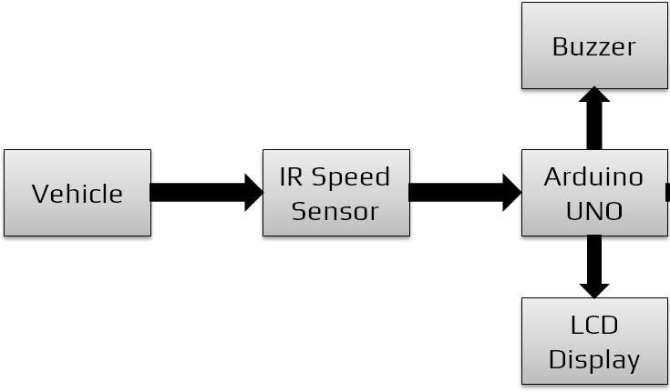

**CIRCUIT DIAGRAM**

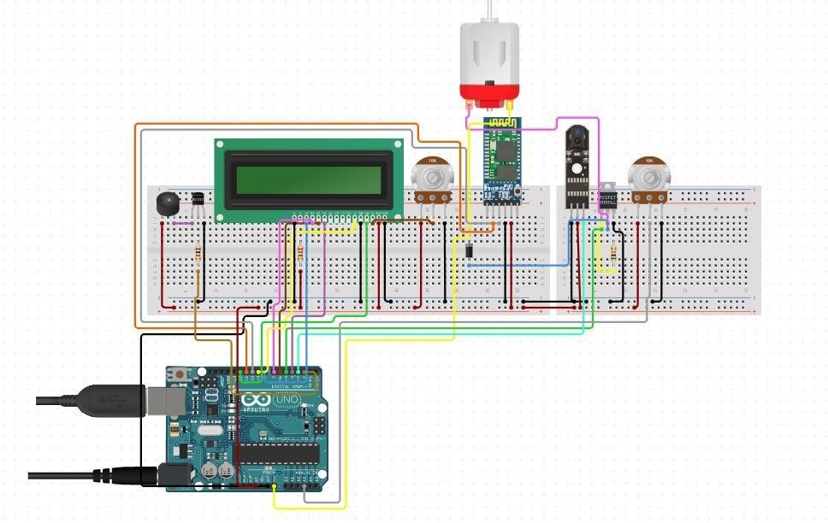

Components used in the System and their Working Principle

## IR Speed Sensor Module based on LM393

This sensor is designed based on IR rays (Infrared Rays). We can mainly use this sensor for measuring the speed of motors and pulse detection.

### Working of IR Speed Sensor:

* + This sensor has two columns: one column includes an IR diode, the other column includes a phototransistor.
  + Upon sensor activation a connection is created between the two columns.
  + The IR diode emits the IR rays which are captured by the phototransistor. This creates a path between the 2 columns.
  + When an object is carried between the two columns, the path is also cut off. The sensor sends us a signal in that situation.
  + We can get the signal as a digital or analog value. Digital values can also be obtained from the LM393 comparator IC in this sensor module.

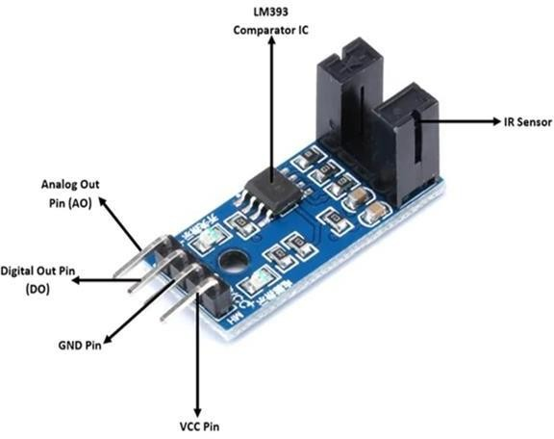

## Arduino UNO

Arduino UNO R3 is a microcontroller board based on the *ATmega328P*. It has 14 digital input/output pins (of which 6 can be used as PWM outputs), 6 analog inputs, a 16 MHz ceramic resonator, a USB connection, a power jack, an ICSP header and a reset button.

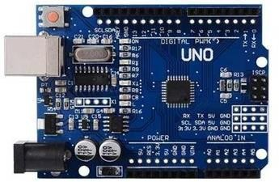

## L298 Motor Driver Module

It is a high power motor driver module for driving DC and Stepper Motors. This module consists of an L298 motor driver IC and a 78M05 5V regulator. *L298N*

*Module* can control up to 4 DC motors, or 2 DC motors with directional and speed control.

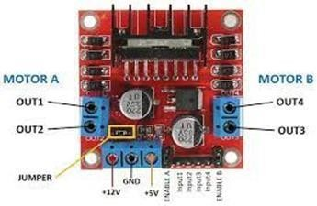

## DC Motor

DC motors (Direct Current) normally have just two leads, one positive and one negative. If you connect these two leads directly to a battery, the motor will rotate. If you switch the leads, the motor will rotate in the opposite direction.

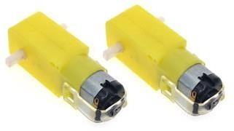

## Breadboard

Breadboard is a way of constructing electronics without having to use a soldering iron. Components are pushed into the sockets on the breadboard and then extra 'jumper' wires are used to make connections.

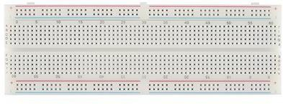

## Alphanumeric Display

LCD display to show the speed and warnings.

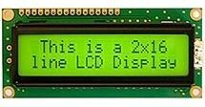

## Passive Buzzer Module

It starts playing the sound only when a pulse is sent from the microcontroller.

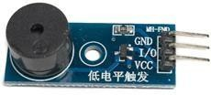

**Determining the motor speed**

* A wheel encoder on the DC motor will help us determine its speed.
* With proper placement, the slots on the encoder will block or pass the IR sensor. This will create a train of pulses whose frequency is proportional to the speed of the motor.
* The wheel encoder pictured has 20 slots.
* Therefore, counting 20 pulses mean the wheel has traveled one revolution.The number of revolutions will then be:

Revolutions = (counter)/20

* Motor speed is normally in revolutions per minute or RPM. Since we have an idea on determining how many revolutions the motor has traveled, all we need is the check the number of revolutions every minute.

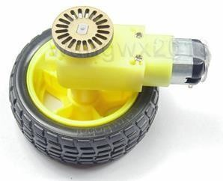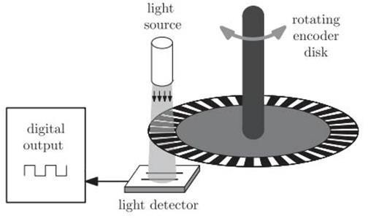

# Arduino Code for the Proposed System

#include <LiquidCrystal.h> #include <SoftwareSerial.h>

int c = 3;

int motorIn1 = 12; int motorIn2 = 13;

SoftwareSerial BTserial(0, 1); // RX | TX int encoder = 2;

volatile unsigned int counter; int rpm;

const int rs = 8, en = 3, d4 = 7, d5 = 6, d6 = 5, d7 = 4;

LiquidCrystal lcd(rs, en, d4, d5, d6, d7);

void setup() { Serial.begin(9600); BTserial.begin(9600); pinMode(9, OUTPUT); pinMode(motorIn1, OUTPUT); pinMode(motorIn2, OUTPUT); pinMode(encoder, INPUT); pinMode(A0,INPUT); digitalWrite(encoder, HIGH); digitalWrite(motorIn1, HIGH); digitalWrite(motorIn2, LOW);

attachInterrupt(0,countpulse,RISING); lcd.begin(16, 2);

}

void countpulse(){

counter++;

}

void loop() {

static uint32_t previousMillis;

if (millis() - previousMillis >= 1000) { rpm = (counter/20)*60; counter = 0;

previousMillis += 1000;

}

int s=analogRead(A0); // 10k Potentiometer int z=map(s,0,1024,0,255);

if(rpm>1500){ if(c>0){

c--;

Serial.println("You are Overspeeding"); Serial.println("Warnings left"); Serial.println(c);

}

if(c==0){

Serial.println("YOU HAVE BEEN FINED FOR OVERSPEEDING");

c--;

tone(9, 2000); delay(1000); noTone(9); delay(1000);

}

}

analogWrite(12,z); lcd.setCursor(0,0); lcd.print("Speed: "); lcd.setCursor(7,0); lcd.print(rpm); lcd.print(" rps"); delay(3000);

}

# Conclusion

The enormous technological advancements and inventions of recent years have had a significant impact on people's lives. Numerous innovations also aimed to improve driving safety. In this paper, we also proposed an Arduino-based method for automatically monitoringand fining over speeding cars on roads without deploying traffic enforcement officers.

Due to their shortcomings, the conventional speed-checking systems used in the transportation sector frequently fail to record the bulk of speeding offenses.

Our suggested method aims to address the issues athand in a way that is both more effective and affordable. This system can be connected toa web network or a mobile application which then can be used to share the data such as vehicle details, speed, time, etc. Such a system has the benefit of requiring very few speed guns to be installed, monitoring vehicles even when they are not in the camera's field of view, and requiring little human involvement.

# Future Scope

The speed monitoring system will eventually be introduced with more features and a more solid business plan as our future goal. One of the key features that can be added to the existing system is:

### Accident Detection:

In order to identify accidents on highways, accident detection systems can be employed in conjunction with vehicle speed monitoring systems. By putting multiple sensors on the road that can track the location and timing of the car, the existing speed monitoring system could be improved. The system can also be modified to alert rescue facilities to the need for immediate help.

# References

## [(PDF) Smart Vehicles Speed Monitoring System Using RFID](https://www.researchgate.net/publication/311739416_Smart_Vehicles_Speed_Monitoring_System_Using_RFID?enrichId=rgreq-e27a17ff5d0aae3d5ffa5715d747442b-XXX&enrichSource=Y292ZXJQYWdlOzMxMTczOTQxNjtBUzo0NDEyOTA1OTM3MDU5OTVAMTQ4MjIyMzI4NDk2NQ%3D%3D&el=1_x_3&_esc=publicationCoverPdf) [(researchgate.net)](https://www.researchgate.net/publication/311739416_Smart_Vehicles_Speed_Monitoring_System_Using_RFID?enrichId=rgreq-e27a17ff5d0aae3d5ffa5715d747442b-XXX&enrichSource=Y292ZXJQYWdlOzMxMTczOTQxNjtBUzo0NDEyOTA1OTM3MDU5OTVAMTQ4MjIyMzI4NDk2NQ%3D%3D&el=1_x_3&_esc=publicationCoverPdf)

1. [**Enabled Vehicle Speed Monitoring System - MDPI**](https://www.mdpi.com/2079-9292/11/4/614)

## [Real Time Automatic Speed Control Unit for Vehicles - IEEE](https://ieeexplore.ieee.org/document/8653721)

1. [**(PDF) Over speed monitoring system - ResearchGate**](https://www.researchgate.net/publication/316721901_Over_speed_monitoring_system)

## [Vehicle Speed Detection System using IR Sensor - Academia](https://www.academia.edu/43313384/Vehicle_Speed_Detection_System_using_IR_Sensor)